**ME 111 Engineering Drawing**

**Lab 9 Intersection of solids Friday Batch**

1. A cylinder 50mm dia.and 70mm axis is completely penetrated by another of 40 mm dia.and 70 mm axis horizontally Both axes intersect & bisect each other. Draw projections showing curves of intersections.

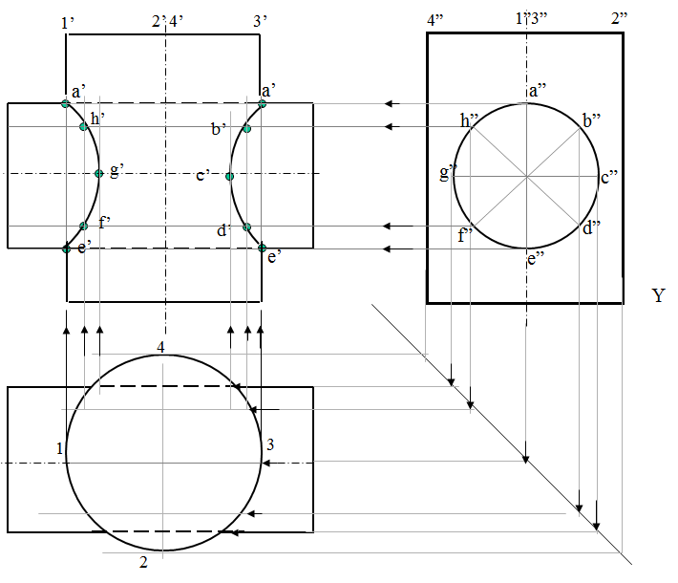

2.0 A sq.prism 30 mm base sides.and 70mm axis is completely penetrated by another square prism of 25 mm sides.and 70 mm axis, horizontally. Both axes Intersects & bisect each other. All faces of prisms are equally inclined to Vp. Draw projections showing curves of intersections.

